SECOND CIRCULAR and CALL for PAPERS

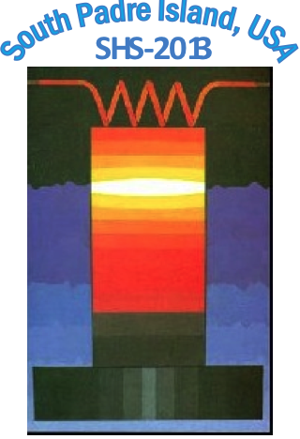
SHS 2013
XII International Symposium on Self-Propagating High Temperature Synthesis
21 - 24 October 2013
(South Padre Island, TX, USA)
Organized by:
- International Association on Self-propagating High-temperature Synthesis (SHS)
- University of Texas at Brownsville

ABOUT THE CONFERENCE
The International Symposium on SHS is held every two years to address both fundamental and application issues of exothermic synthesis and processing of materials. The previous meetings were held in:
• Kazakhstan (Alma-Ata, 1991)
• USA (Honolulu, 1993)
• China (Wuhan, 1995)
• Spain (Toledo, 1997)
• Russia (Moscow,1999)
• Israel (Hajfa, 2002)
• Poland (Cracow, 2003)
• Italy (Cagliari, 2005)
• France (Dijon, 2007)
• Armenia (Tsakhadzor, 2009)
• Greece (Eden, 2011)

The symposium is now one of the most important events in SHS science and technology. The aim of the Symposium is to overview the global trends and recent achievements in the field of Self-propagating High-temperature Synthesis of Advanced Materials and to demonstrate the broader impact of this direction for scientific and industrial communities worldwide.
CONFERENCE TOPICS
The SHS-2013 will bring together experts from all over the world to exchange information on key topics including:

• SHS of micron, submicron- and nano- materials
• Nanoenergetic materials and processes
• Combustion of multilayered nano-structures
• Biomaterials and coatings
• Combustion theory and modeling
• Packing geometry in nano- and micro- scale
• Sintering and consolidation
• Space applications
• Industrialization

The symposium technical program will have three parallel sessions, which will be held over four days. The topics will be addressed in invited plenary lectures, selected oral presentations, and poster sessions. Posters will be displayed for the duration of the symposium to encourage spontaneous discussions. In addition, a special round table discussion will be organized.

ORGANIZING COMMITTEE
A. G. Merzhanov, Russia (Chairman)
K. S. Martirosyan, USA (Co-Chairman)

INTERNATIONAL COORDINATORS
Alexander S.Mukasyan (USA)
Alexander E. Sytschev (Russia)

LOCAL ORGANIZING COMMITTEE
Chairperson: Karen Martirosyan, (USA)
Co-chairman: Alexander Mukasyan, (USA); Timothy Weihs (USA); Edward Dreizin (USA); Jainagesh Sekhar (USA); Steven Son (USA); Mario Diaz (USA); Mikhail Bouniaev (USA); Luis Colom (USA); Lori Groven (USA); Yasuyuki Horie (USA); Sidney Lin (USA)

INTERNATIONAL ADVISORY BOARD:
A.P. Amosov (Russia); J. Aruna (India); F. Bernard (France); V.A. Borodulya (Belarus); I.P. Borovinskaya (Russia); G. Cao (Italy); C.-C. Ge (China); E. Gutmanas (Israel); A. Hayhurst (UK); S. Kharatyan (Armenia); G. Ksandopulo (Kazakhstan); E.A. Levashov (Russia); N.Z. Lyakhov (Russia); Yu.M. Maksimov (Russia); D. Luss (USA); Z. Munir (USA); O. Odawara (Japan); G. Oniashvili (Georgia); O. Yucel (Turkey); K.C. Patil (India); J. Puszynski (USA); A.S. Rogachev (Russia); G. Tavadze (Georgia); N.N. Thadhani (USA); Z. Mansurov, (Kazakhstan); P. Vincenzini (Italy); D. Vrel (France); C.W. Won (Korea); G. Xanthopoulou (Greece)

ABSTRACTS SUBMISSION
Participants wishing to present a contribution are asked to prepare an Extended Abstract (2 A4 pages) according to the formatting instructions available on: http://nano.phys.utb.edu. The deadline for Abstract submission is April 15, 2013. Acceptance notification is May 15, 2013. Conference official language is English.

PROCEEDINGS
An Extended Abstract book will be distributed at the Conference desk. A copy will be available in advance on conference webpage. Accepted papers will be published in a Special Issue of the International Journal of Self-propagating High-temperature Synthesis.

SPONSORS & EXHIBITORS
Companies wishing to exhibit related equipment and apparatus during the symposium are welcome. Please contact the conference secretariat.
Key Deadlines:
Abstract submission due: April 15, 2013
Acceptance notification: May 15, 2013
Early registration deadline: August 1, 2013 Questions & Info: karen.martirosyan@utb.edu

