
SHS 2013
XII International Symposium
on Self-Propagating High Temperature Synthesis
21 - 24 October 2013
(South Padre Island, TX, USA)

Key Deadlines:

1st announcement call for papers: 1 August 2012
2nd announcement call for papers: 15 December 2012
Abstract Submission: 15 April 2013
Acceptance notification: 15 May 2013
Registration Deadline: 1 August 2013

Dear Colleagues,

It is a great pleasure to invite you to participate in the XII International Symposium on Self-Propagating High Temperature Synthesis (SHS), which will be held in South Padre Island, TX, USA on 21 - 24 October 2013. The symposium offers great opportunity to gain information on recent discoveries, novel fundamental and technological achievements in the field of synthesis and processing of advanced materials. We are enthusiastic about the privilege of hosting SHS-2013 and will make our best to ensure its success. Look forward to seeing you all in South Padre Island at the Pearl South Padre Hotel.
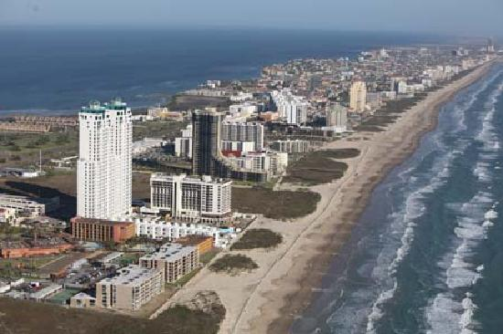


Main Objective:
The aim of the Symposium is to overview the global trends and recent achievements in the field of Self-propagating High-temperature Synthesis (SHS) of Advanced Materials and to demonstrate the broader impact of this direction for scientific and industrial communities worldwide.

Venue:
Continually ranked as one of the top 10 beaches in the U.S., South Padre Island provides the perfect backdrop for outdoor fun. The island's mild climate lends itself to an array of water-related sports and other outdoor activities year-round. Visitors can enjoy Texas hospitality coupled with the island’s small-town charm. Pearl South Padre Hotel http://www.pearlsouthpadre.com located on the island's southern tip, the hotel is a premier oceanfront resort with tranquil views and soft sand beaches in South Texas. Warm rays of sunshine and tropical breezes await your arrival.

Goals:
- To overview the state of the art directions in the field of SHS with regard to the global trends in materials design, processing and applications;
- To share and discuss the ideas on novel SHS-based approaches and technologies to enable more effective their penetration in various industrial fields;
- To serve as a platform for discussion on the innovative methodologies and techniques to plan the future of SHS;
- To involve young scientists and engineers to ensure the successful continuation of the research both in fundamental and applied areas;
- To boost the international collaboration among the scientific communities, working in the field of synthesis of advanced materials.

Preliminary Symposium Topics:
- SHS of micron, submicron- and nano- materials
- Nanoenergetic materials and processes
- Combustion of multilayered nano-structures
- Bio materials and coatings
- Combustion theory and modelling
- Sintering and consolidation
- Space applications
- Industrialization

GENERAL CHAIRMAN:
Alexander G. Merzhanov (Russia)

DEPUTY CHAIRPERSON:
Karen Martirosyan (USA)

INTERNATIONAL COORDINATORS:
Alexander S.Mukasyan (USA)
Alexander E. Sytschev (Russia)

LOCAL ORGANIZING COMMITTEE:
Chairperson: Karen Martirosyan, (USA)
Co-chairman: Alexander Mukasyan, (USA)
Timothy Weihs (USA)
Edward Dreizin (USA)
Steven Son (USA)
Mario Diaz (USA)
Mikhail Bouniaev (USA)
Luis Colom (USA)
Lori Groven (USA)
Yasuyuki Horie (USA)
Jainagesh Sekhar (USA)

INTERNATIONAL ADVISORY BOARD:
A.P. Amosov (Russia)
J. Aruna (India)
F. Bernard (France),
V.A. Borodulya (Belarus)
I.P. Borovinskaya (Russia)
G. Cao (Italy)
C.-C. Ge (China)
E. Gutmanas (Israel)
A. Hayhurst (UK)
S. Kharatyan (Armenia)
G. Ksandopulo (Kazakhstan)
E.A. Levashov (Russia)
N.Z. Lyakhov (Russia)
Yu.M. Maksimov (Russia)
D. Luss (USA)
Z. Munir (USA)
O. Odawara (Japan)
G. Oniashvili (Georgia)
O. Yecel (Turkey)
K.C. Patil (India)
J. Puszynski (USA)
A.S. Rogachev (Russia)
G. Tavadze (Georgia)
N.N. Thadhani (USA)
P. Vincenzini (Italy)
D. Vrel (France)
C.W. Won (Korea)
G. Xanthopoulou (Greece)
Sekhar Jainagesh (USA)

