III French–Russian Workshop on SHS and Reactive Nanosystems
Université de Bourgogne, Dijon, October 2–6, 2010
(supported by CNRS and RFBR, project no. 10-03-91101-z)

http://www.ism.ac.ru/events/fra-rus_workshop3/index.php
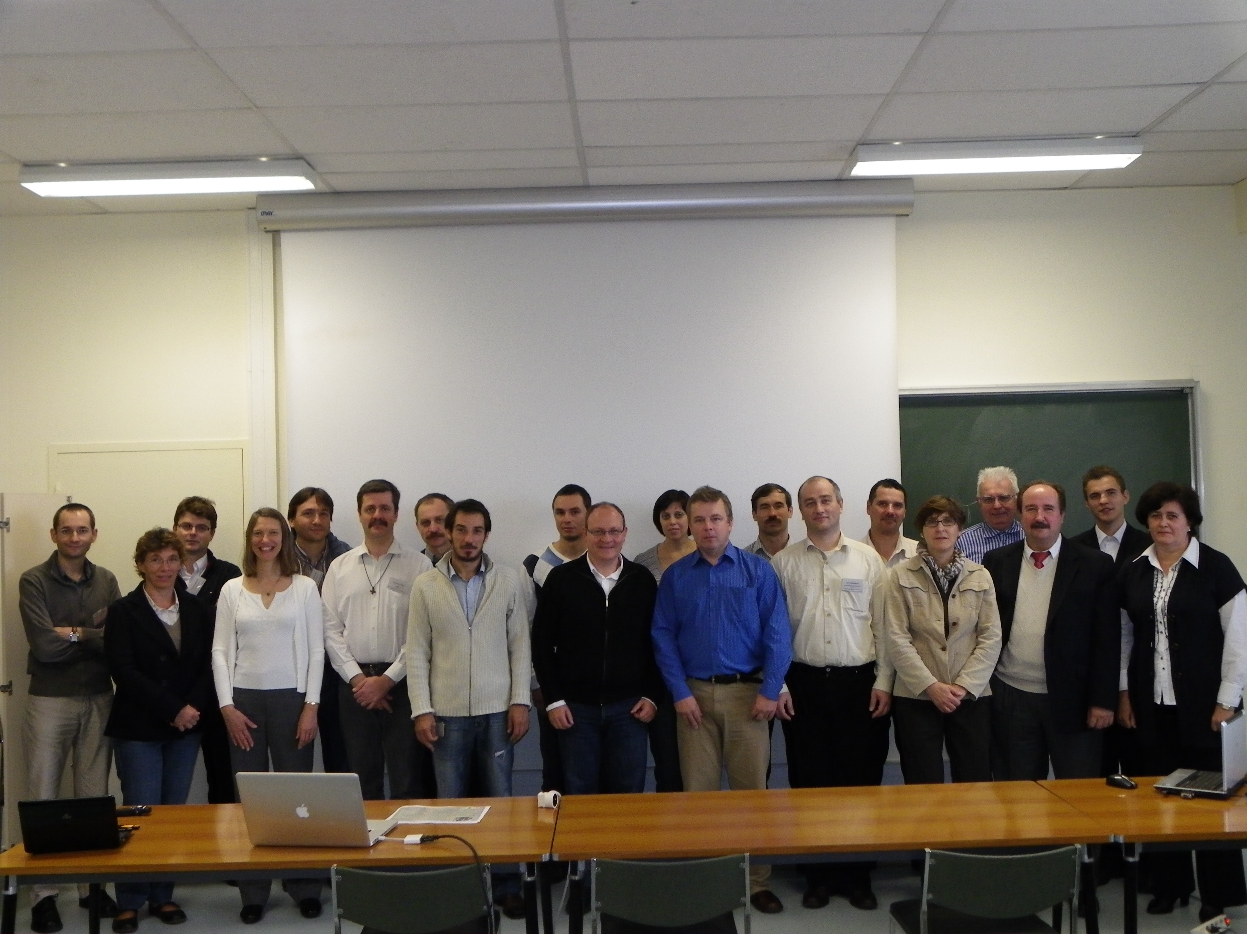

The workshop addressed to current problems in combustion synthesis of materials, with special emphasis on reactive nanosystems, was actually a continuation of two previous Russian–French workshops on SHS: the first one was held in 2003 in Chernogolovka, Russia, while the second one, in 2006 at Université de Paris-Nord Villetaneuse (Paris 13).
The idea of this workshop came from Prof. Florence BARAS, Prof. Frederic BERNARD, Prof. Jean-Claude NIEPCE (all of Université de Bourgogne) and also from Prof. Alexander MERZHANOV and Prof. Alexander ROGACHEV (both of ISMAN). A financial support was provided by the Russian Foundation for Basic Research (RFBR) and Centre National de la Recherche Scientifique (CNRS).

Among participants, there were representatives of the Institute of Structural Macrokinetics and Materials Science, National Technolological University MISiS, Bauman State Technical University, Institute of Solid-State Chemistry and Mechanochemistry (Russia), Université de Pierre et Marie Curie, Université de Montpellier II, Université de Bourgogne, Université de Limoges, Université Paris 13, and Université Paris 6 (France).

The technical program covered the following topics:

- SHS: theory, experiment, applications
- Spark plasma sintering and SHS
- Phenomenology and mechanism of solid-flame combustion
- Solid–gas reactions and infiltration-mediated combustion
- Crystal structure and morphology of SHS products
- Mechanical activation of SHS
- Combustion of heterogeneous nanosystems
- Combustion of solutions
- Time-resolved X-ray diffraction
It is generally admitted that the workshop markedly promoted the coordination of joint efforts of Russian and French researchers active in the field of SHS and reactive nanosystems.
It was also decided to set up a French–Russian work group on combustion synthesis for conducting joint research projects.

