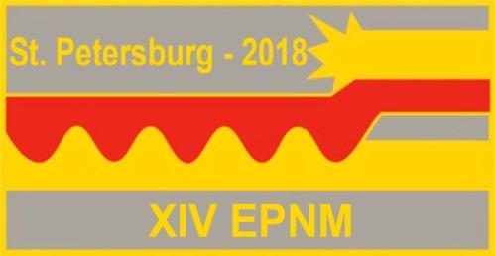
XIV International Symposium on Explosive Production of New Materials: Science, Technology, Business, and Innovations (EPNM-2018)

Registration form

First name
Middle name
Last name
Degree (title/position)
Institution/Organization
Address
Telephone
Fax
e-mail
I will participate (with presentation/ without presentation)
Kind of presentation (oral/poster)
Title of the paper and authors
I will be accompanied

