EXPLOSIVE WELDING OF TITANIUM AND MAGNESIUM ALLOY USING CONVEMTIONAL AND UNDERWATER SHOCK WAVE TECHNIQUES

M. A. Habib¹, A. Mori², S. Tanaka¹, and K. Hokamoto¹

¹Kumamoto University, 2-39-1 Kurokami, Chuo-ku, Kumamoto, 860-8555 Japan
²Sojo University, 4-22-1 Ikeda, Nishi-ku, Kumamoto, 860-0082 Japan

e-mail: hokamoto@mech.kumamoto-u.ac.jp

It is known that the welding and joining of magnesium alloy and other materials are very difficult due to the high reactivity and low melting point. The explosive welding technique is one of the candidates processes that would enable to join dissimilar materials. The explosive welding of aluminum plate with AZ31 magnesium alloy plate was successfully achieved by Ghaderi et al. [1] using conventional explosive welding technique. In the present work we explored the explosive welding of titanium and magnesium alloy AZ31.
In preliminary experiments, the explosive welding of a titanium flyer plate (JIS TP270, 3 mm thick) with an AZ31 base plate was performed using the conventional technique. The ammonium nitrate based explosive PAVEX (detonation velocity
2–2.5 km/s, density 550 kg/m³) produced by Asahi-Kasei Chemicals Corp was employed. The thickness of explosive layer, t_{e}, was varied between 40 and 30 mm. The experimental results (Fig. 1) suggest that the welding was not successful. One sample remained unjoined (Fig. 1a) while another, partially welded and the interface had a thick fused layer close to the wavy interface (Fig. 1b).
(a) (b)
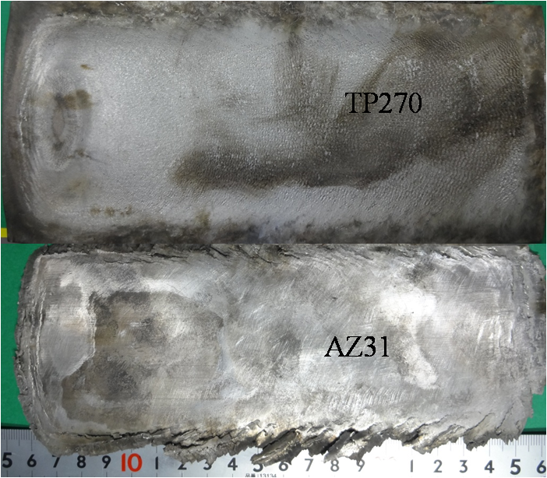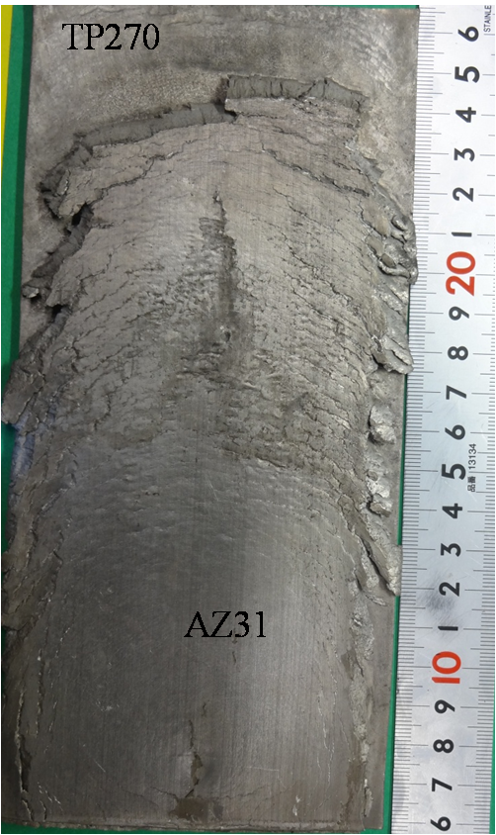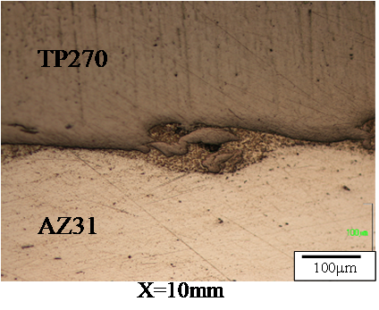
100μm

Fig. 1. Explosive welding of titanium and AZ31 using conventional technique:
t_{e} = 40 (a) and 30 mm (b).

Underwater explosive welding experiments were performed using the assembly developed so far [2–4] and illustrated in Fig. 2. We used an inclined set-up of explosive because the high-explosive SEP (Asahi-Kasei Chemicals Corp) had a detonation velocity of 7 km/s (density 1300 kg/m³). There were two types of assembly: one enabled to get uniform pressure distribution through the sample while the other (fixed thickness) gave different pressure above the sample along horizontal coordinate x. In the present investigation, we employed the latter, t_{e} = 5 mm, in order to get results at different experimental conditions in one experiment. Titanium plate and AZ31 plates were welded in the presence of AZ31 intermediate plate as to decrease the energy dissipated by collision. Without the intermediate plate, a thick molten zone was formed at the interface.

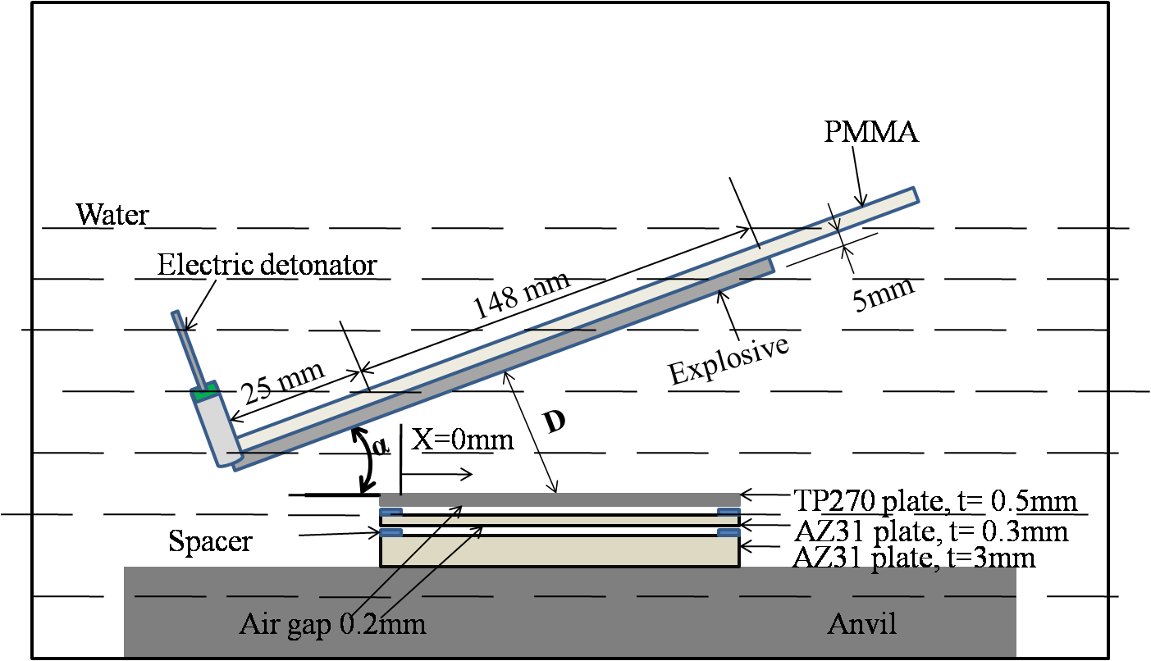

Fig. 2. Assembly for underwater explosive welding with a fixed thickness of explosive layer.

The welding quality was markedly modified by using the underwater explosive welding with an intermediate plate. Figure 3 shows the microstructure of thus obtained joint under moderate conditions (α = 20°, D = 35mm) for different coordinate x. Though the interface showed planar structure due to the difference of the properties, a good quality welding has been achieved.

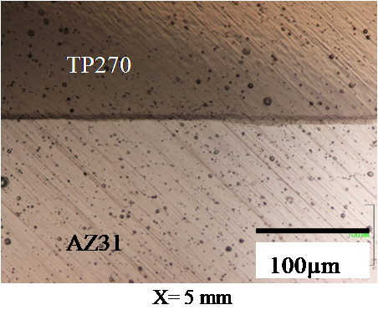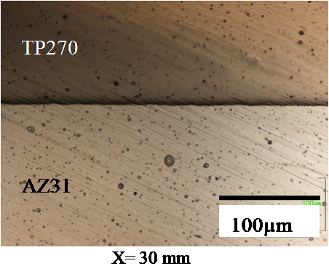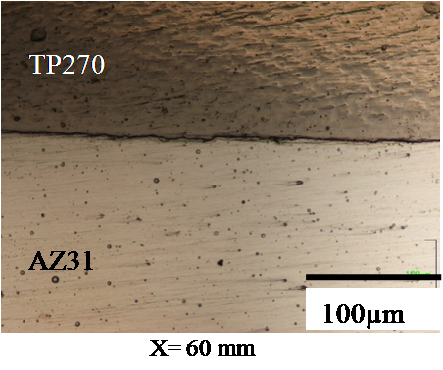
100μm
100μm
100μm
(a) X = 5 mm (b) X = 30 mm (c) X = 60 mm

Fig. 3. Microstructure of TP270 and obtained under moderate condition using intermediate plate.

The underwater explosive welding technique developed here has an advantage to accelerate a thin plate with a short stand-off distance and the appearance is quite good finishing by the use of water as a pressure transmitting medium. The welding conditions will be discussed based on the concept of welding wind developed by Deribas and Wittman [5] and the results of numerical simulation will be demonstrated at presentation.

- S.H. Gaderi, P. K. Hokamoto, A. Mori, Analysis of explosively welded aluminum-AZ31 magnesium alloy joints, Mater. Trans., 2008, vol. 49, no. 5, pp. 1142–1147.
- P. Manikandan, J.O. Lee, K. Mizumachi, A. Mori, K. Raghukandan,
K. Hokamoto, Underwater explosive welding of thin tungsten foils and copper,
J. Nucl. Mater., 2011, vol. 418, nos. 1–3, pp. 281–285.
- K. Hokamoto, K. Nakata, A. Mori, S. Tsuda, T. Tsumura, A. Inoue, Dissimilar material welding of rapidly solidified foil and stainless steel plate using underwater explosive welding technique, J. Alloys Comp., 2009, vol. 427,
nos. 1–2, pp. 507–511.
- P. Manikandan, K. Hokamoto, M. Fujita, K. Raghukandan, R. Tomoshige, Control of energetic conditions by employing interlayer of different thickness for explosive welding of titanium/304 stainless steel, J. Mater. Process. Technol., 2008, vol. 195, nos. 1–3, pp. 232–240.
- B. Crossland, Explosive Welding of Metals and Its Application, Oxford: Oxford University Press, 1982.

