USE OF EXPLOSION ENERGY FOR PRODUCTION OF NEW MATERIALS AND COATINGS

A. A. Shtertser, V. Yu. Ul'yanitskii, and A. S. Yunoshev

Lavrent'ev Institute of Hydrodynamics, Siberian Branch, Russian Academy of Sciences, pr. Lavrent'eva 15, Novosibirsk, 630090 Russia

e-mail: asterzer@mail.ru

It is commonly known that the energy of explosives can be used for production of composite materials. At that there are two states of explosive: condensed (solid, liquid, and powdered) and gaseous. The best examples of industrial application of condensed explosives are explosive welding, explosive loading of powdered materials, explosive forming, and explosive hardening. Gaseous detonation is successfully used for deposition of multilayer coatings by detonation spraying. In this communication, we discuss the possibility of fabricating bulk samples and coatings using explosive technologies.
The compaction of β-FeSi₂ powder is an example of using high explosives in order to make bulk samples from powdered material. This material is a promising one for production of thermoelectric units. It has a thermo electromotive force of about 450 μV/K and in some cases can compete with commonly used bismuth telluride (Bi₂Te₃) and lead telluride (PbTe). The powder containing β-FeSi₂ was made by mechanochemical route in a 2SL high-energy mechanical activator. Addition of Co and Al into Fe +2Si mixtures permits to obtain n-type (Fe_{0..94}Si₂Co_{0.06}) and p-type (FeSi_{1.94}Al_{0.06}) semiconductors. The XRD data (D8 Advance, Bruker) shows the formation of different Fe–Si phases (see the Table below) such as Fe₃Si, ε-FeSi, and β-FeSi₂ [1]. The densities of ε-FeSi, Si, β-FeSi₂, and α-FeSi₂ are 6.37, 2.3, 4.93, and 4.99 g/cm³, respectively [2, 3]; therefore, calculation gives the values of 5.17 and 5.18 g/cm³ for p- and n-type material, respectively.

 | Atomic %
p-Type material (FeSi_{1–x}Al_{x})
Cubic iron silicide (ε-FeSi)  Orthorhombic semiconducting β-FeSi₂  Tetragonal iron disilicide (metal phase α-FeSi₂)  Silicon | 31  62  3  4
n-Type material (Fe_{1–x}Co_{x}Si₂)
Cubic iron silicide (ε-FeSi)  Orthorhombic semiconducting β-FeSi₂  Tetragonal iron disilicide (metal phase α-FeSi₂)  Silicon | 36  53  4  7

A material containing β-FeSi₂ is brittle and the great problem is cracking of samples prepared by dynamic compaction. Compaction was performed in cylindrical geometry (Fig. 1). Experiments have shown that optimal detonation velocity was 4.0–4.5 km/s (explosive based on amatol). The obtained specimens are shown in Fig. 2. Compact density is 4.4 g/cm³, electric resistance 2∙10^{–3} Ω∙m.
The main problem now is to provide reliable synthesis of powdered material with maximal content of β-FeSi₂. Besides, cracking of compacts is often observed. It can be possibly overcome by using of long-pulse explosive compaction [4].

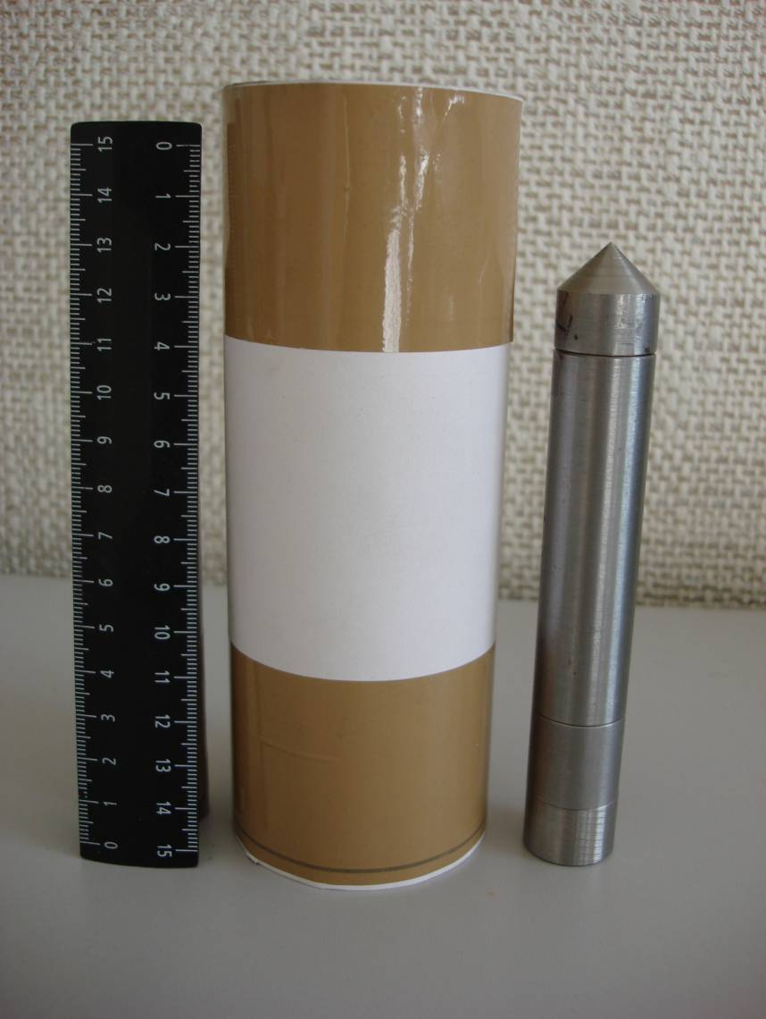 | 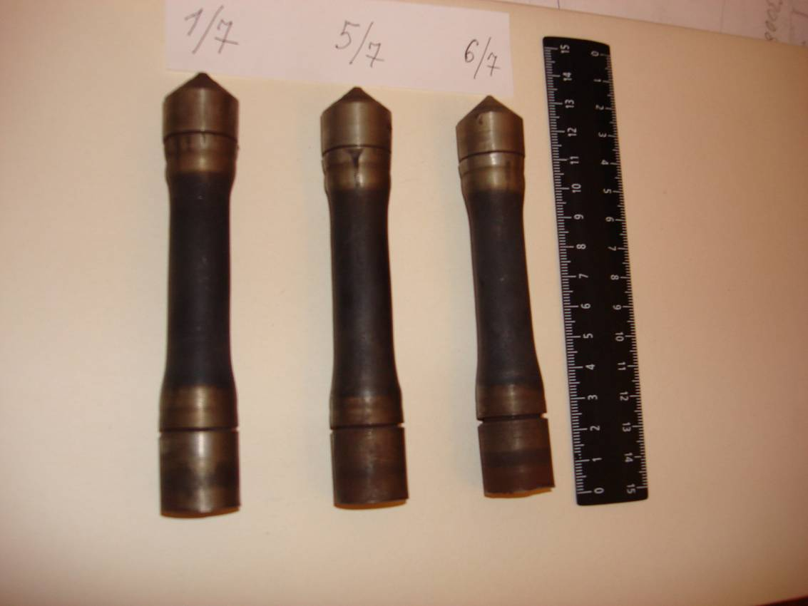

Fig. 1. Container with a powder and carton cylinder for explosive charge (left) and containers after explosive loading (right).

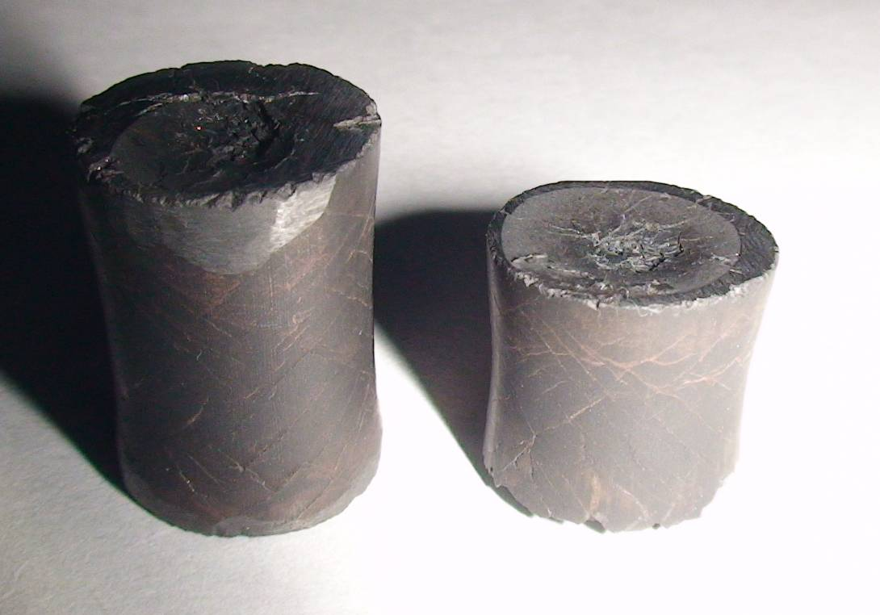

Fig. 2. Cylindrical compacts.

Detonation spraying is another explosive technology for deposition of numerous coatings. Graded Al₂O₃–Ti coatings and multilayered coatings (WC/Co–Cu, Ti–Cu, etc.) were obtained using Computer Controlled Detonation Spraying (CCDS) with two powder feeders [5]. Figure 3 shows the graded Al₂O₃–Ti coating for use as a thermal barrier layer in different machine parts (e.g. gas turbine blades). Our tests have shown that gradient Al₂O₃–Ti coating had much better resistance to failure in thermal cycling conditions (as compared to Al₂O₃).
Figure 4 shows the graded composite coating of WC–Co–Cr hard alloy deposited onto copper. It demonstrates the high potential of CCDS technology in the design of multilayered composite coatings. Recently the new CCDS-2000 facility was designed which can be mounted on an industrial robot and used for deposition of coatings on the surfaces with sophisticated profiles (Fig. 5).

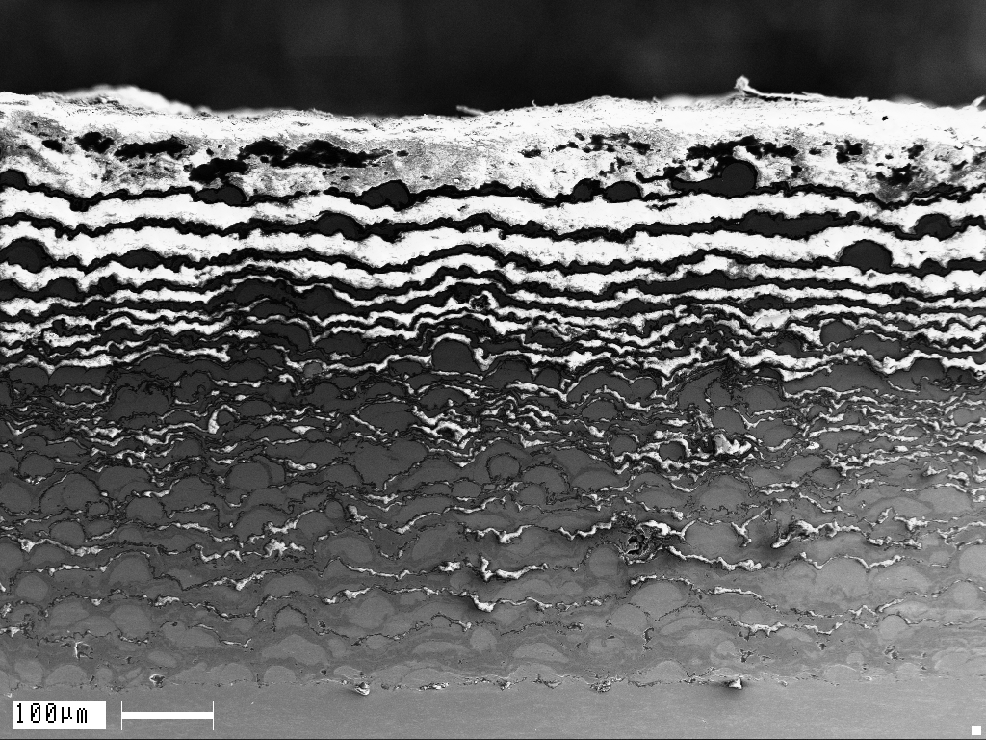 | 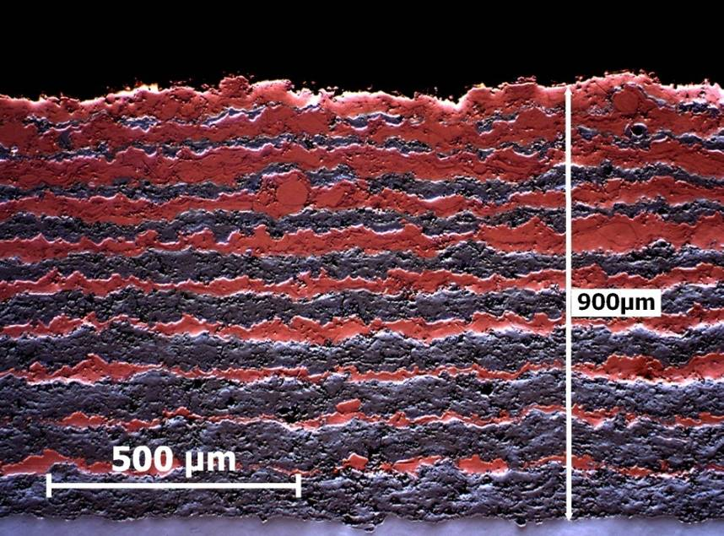
Fig. 3. Gradient Al₂O₃–Ti coating on Ti substrate. Number of layers 25, coating thickness ∼500 µm. | Fig. 4. Transition layer between WC–Co–Cr (86–10–4 wt %)  and Cu (top).

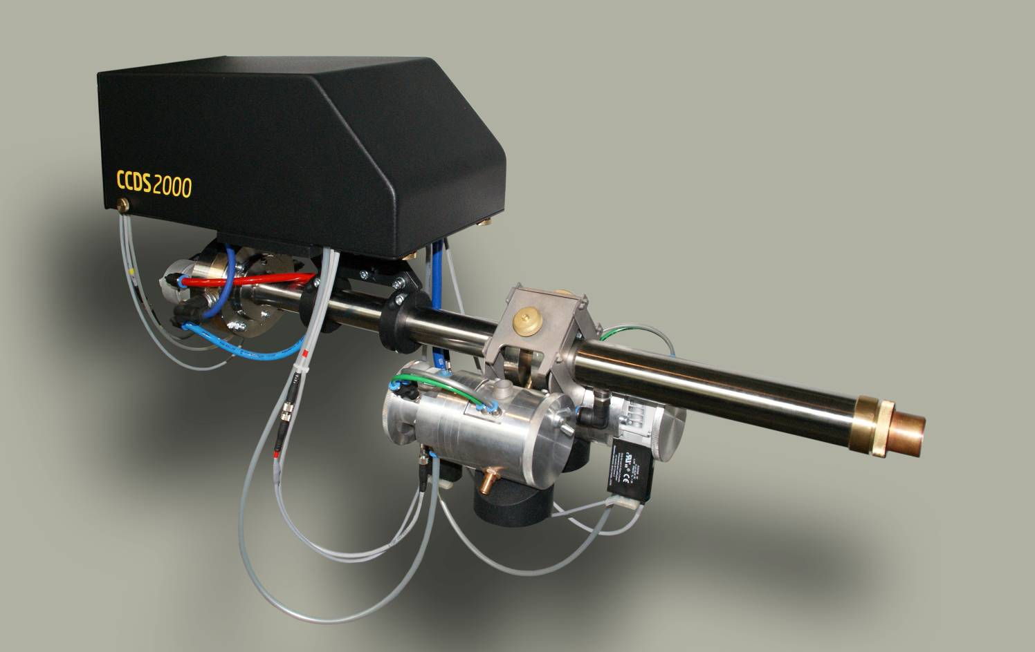

Fig. 5. CCDS-2000 detonation gun compatible with industrial robot.

This work was supported by the Russian Academy of Sciences (project no. 22.17), Russian Foundation for Basic Research (project no. 09-01-00433-a), Siberian Branch of the Russian Academy of Sciences (integration projects nos. 82, 108), Program for Russian Scientific Schools (project no. 1886.2008.1), and International Science and Technology Center (grant no. 3250).

- M.V. Gomoyunova, D.E. Malygin, I.I. Pronin, Deposition of Ultrathin Iron Silicide Layers onto the Surface of Silicon Single Crystal, Fiz. Tverd. Tela, 2006, vol. 48, no. 10, pp. 1898–1902.
- A.E. Vol, Stroenie i svoistva dvoinykh metallicheskikh system (Structure and Properties of Binary Metallic Systems), Moscow: Gos. Izd. Fiz.-Mat. Lit., vol. 2, 1962.
- D.M. Rowe, Thermoelectrics Handbook: Macro to Nano, CRC Press, 2006.
- A.A. Deribas, P.A. Simonov,V.N. Filimonenko, and A.A. Shtertser, Long-Pulse Explosive Compaction of Diamond Powder, Combust. Explos. Shock Waves, 2000, vol. 36, no. 6, pp. 758–770.
- A.A. Shtertser, V.Yu. Ulianitsky, S.B. Zlobin, Use of Detonation Spraying for Formation of Gradient Coatings, Uprochn. Technol. Pokr., 2010, no. 11, pp. 30–35.

