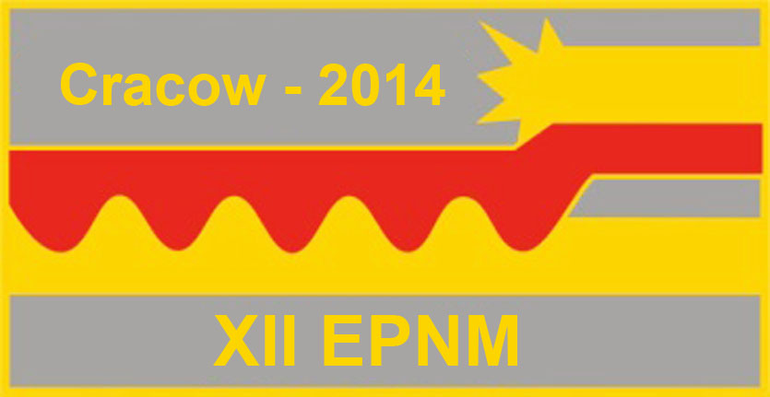
XII International Symposium
on Explosive Production of New Materials:
Science, Technology, Business, and Innovations
(EPNM-2014)

Registration form

First name
Middle name
Last name
Degree (title/position)
Institution/Organization
Address
Telephone
Fax
e-mail
I will participate with presentation
I will participate without presentation
Tentative title of presentation (oral/poster)

