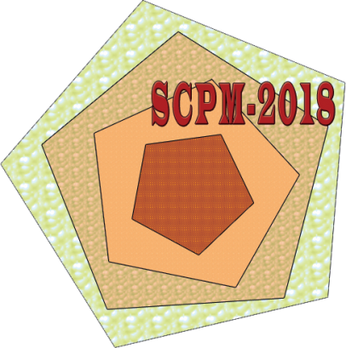
International Conference
on Synthesis and Consolidation
of Powder Material
(SCPM-2018)

October 23–26, 2018, Chernogolovka, Moscow Region, Russia

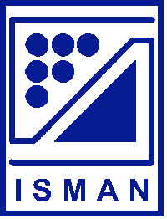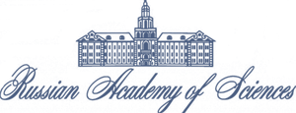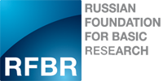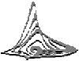

Registration form

First name
Middle name
Last name
Degree (title/position)
Institution/Organization
Address
Telephone
Fax
e-mail
I will participate (with presentation/ without presentation)
Kind of presentation (oral/poster)
Title of the paper and authors
I will be accompanied

