SYNTHESIS OF FUNCTIONAL MATERIALS FOR NUCLEAR ENGINEERING: TEMPERATURE PROFILE OF SHS REACTION

D. G. Demyanyuk, O. Yu. Dolmatov, D. S. Isachenko,
M. S. Kuznetsov, and А.О. Semenov

National Polytechnic University, pr. Lenina 30, Tomsk, 634050 Russia

e-mail: isachenko@tpu.ru

As is known [1–3], SHS-produced tungsten boride WB and boron carbide BC are being regarded as candidates for their potential use in nuclear power engineering. In the synthesis of these materials, of current importance is distribution of temperature over an SHS reactor.
In this communication, we report some our results on theoretical and experimental estimation of temperature profiles of SHS reactions using the following equation of thermal conductivity with a movable heat source:

(1)

where a(T) is the thermal diffusivity, C(T) heat capacity, ρ density, and q_{V} volumetric heat source.
Initial conditions:

.

Boundary conditions:

(2)
(3)

where α is the heat transfer coefficient, ε emissivity, σ Stefan–Boltzmann constant, T temperature, T₀ initial temperature, and T_{in} the initiation temperature.

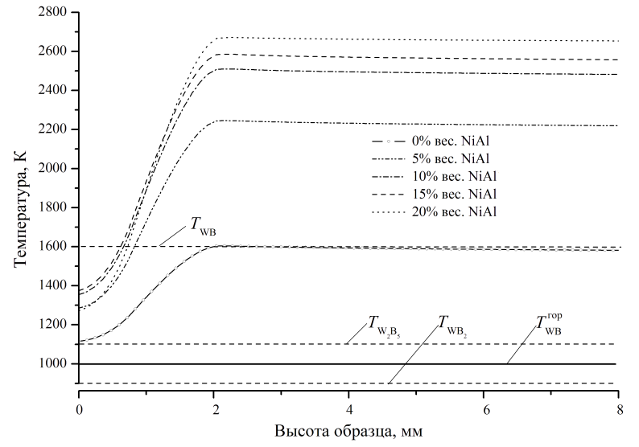
h, mm
T, K

Fig. 1. Distribution of temperature T over sample height h for different values of q at t = 0.2 s after reaction initiation.

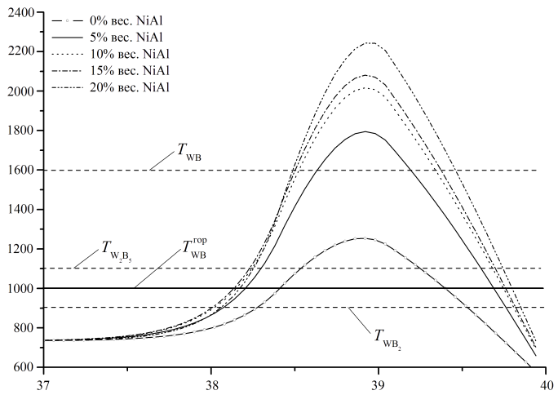
0 wt % NiAl
5 wt % NiAl
10 wt % NiAl
15 wt % NiAl
20 wt % NiAl
h, mm
T, K

Fig. 2. Distribution of temperature T over sample height h for different values of q at t = 3.8 s after reaction initiation.

Figures 1 and 2 show the distribution of temperature T over sample height h for different values of q at t = 0.2 and 3.8 s after reaction initiation. Horizontal lines indicate lower limits for formation of WB, WB₂, and W₂B₅.

Amount of added NiAl, wt % | Phase composition
Amount of added NiAl, wt % | Calculated | Found
0 | WB, WB₂, W₂B₅ | WB, WB₂, W₂B₅, WO₃
15 | WB, WB₂ | WB, WB₂, WO₃, Ni₃Al

The results of calculations and experiments were found (see the Table above) to reasonably agree.

- Boiko V.I., Demyanyuk D.G., Dolmatov O.Yu., Isachenko D.S., Shamanin I.V., Combustion Synthesized Materials for Radiation Protection: Rated Research, Izv. Tomsk. Politekh. Univ., 2005, vol. 308, no. 6, pp. 80–83.
- Novikov N.P., Borovinskaya I.P., Merzhanov A.G., in Combustion Processes in Chemical Engineering and Metallurgy, Merzhanov A.G., Ed., Chernogolovka, 1975, pp. 174–188.
- Demyanuk D.G., Dolmatov O.Yu., Ryzhkevich M.P., Application of Self-propagating High-Temperature Synthesis to High-Current Electronics, Int. J. SHS, 2004, vol. 13, no. 2, pp. 183–192.

